**Settings in Electric P8:**

1. After installing EPLAN v2.9 in client system, open Electric P8 and set “Parts / Translation / Project” databases in SQL Server (don’t create database, only select existing database)
   1. Go to menu **Options → Settings**, then under *User → Management → Parts*, import the scheme “PSds.SQL_Parts.xml”. Then click on [**…**] button and check details are showing as below

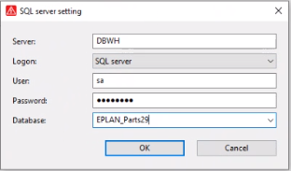

* 1. Go to menu **Options → Settings**, then under *User → Translation → Dictionary*, select “**SQL server**” and click on [**…**] button to enter server details including existing Translation database

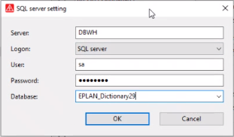

* 1. Go to menu **Options → Settings**, then under *User → Management → Project management database*, select “**SQL server**” and click on [**…**] button to enter server details including existing Project database

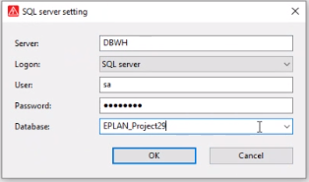

1. In Electric P8, change Directory settings to server location. Go to menu **Options → Settings**, then under *User → Management → Directories*, import the scheme “MDps.G_Electricals_EPLAN29.xml”. This will set all master data path to G_Electricals server.

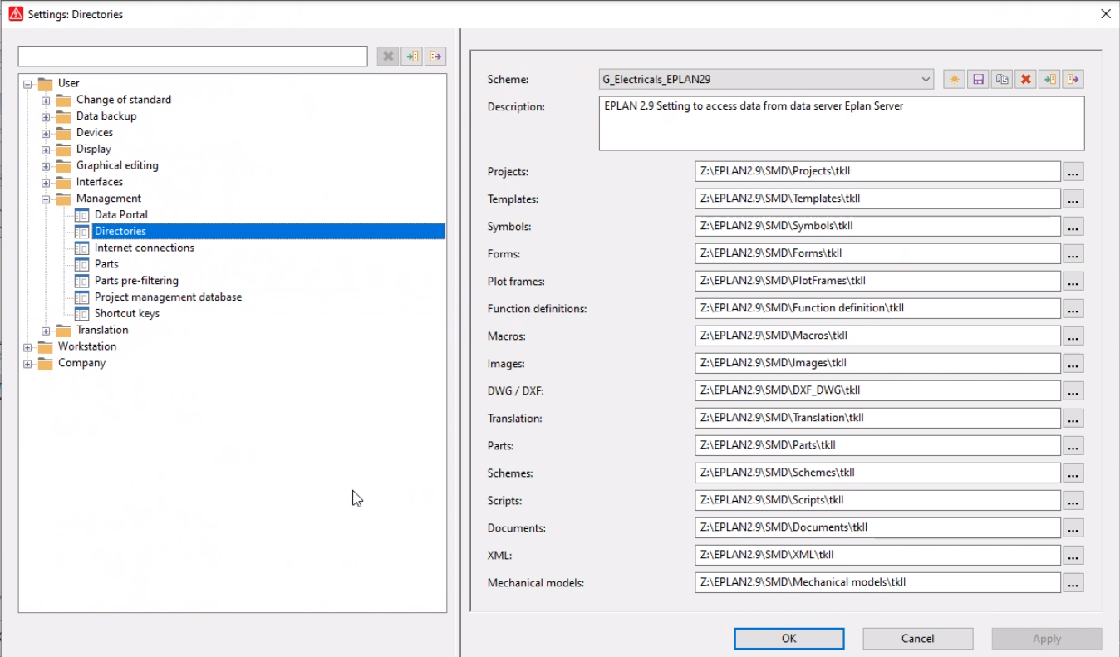

1. Import the schemes, in respective dialog as given below:
   1. **LB.tkII_Summarized_Parts_List.xml**: From “*Utilities → Manufacturing data → Export / Labelling*“ for Summarized Parts List
   2. **LB.tkII_Ferruling_list_xls.xml**: From “*Utilities → Manufacturing data → Export / Labelling*“ for Ferrule list
   3. **LB.tkII_Connection_List.xml**: From “*Utilities → Manufacturing data → Export / Labelling*“ for Connection list
   4. **LB.tkII_Cable_overview_multiTarget.xml**: From “*Utilities → Manufacturing data → Export / Labelling*“ for Cable overview
   5. **PXex.tkII_Cables.xml**: From “*Utilities → Edit properties externally → Export data*“ for Editing Cable data externally
   6. **APsc.tkII_Automated_Output.xml**: From “*Utilities → Automated processing*“, then click on [**…**] button and import scheme for *Automated processing*
   7. **GOpj.tkII_ProjectProperties.xml**: In project properties dialog, select “User-defined” in “Category” drop-down list, then right-click and select *Configure* pop-up menu and in next dialog import *Project properties* scheme

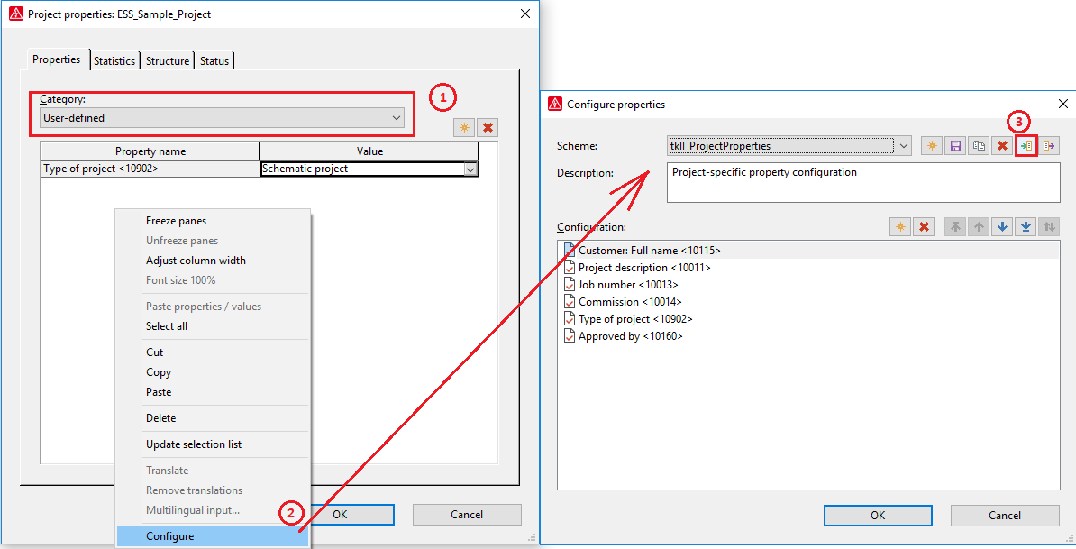

Note: During import of scheme files, if same scheme exists in your EPLAN system, delete the scheme first, then import.

1. Now add EEC One in EPLAN menu.
   1. Go to menu point ***Options => External programs***
   2. Click on ***Add*** button in next dialog
   3. Write in ***Menu*** field “EEC One”
   4. Select EEC One icon on your desktop and go to Properties from pop-up menu
   5. Under *Shortcut* tab, copy path from *Target* field
   6. Paste same path in ***Command*** field….. Check command value is without “, see picture below

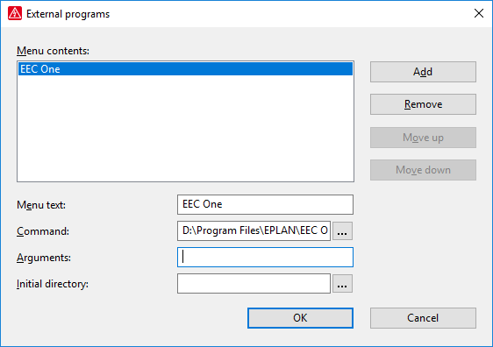

1. In your system master data, image files “EEC1.bmp”, “EditExternal.bmp”, “Automate.jpg” must be available under …**Images\tkII** folder and “tkII_Toolbar.xml” file must be available under …**XML\tkII** folder
2. Load script “**EditCableData.cs**”, from menu point *Utilities → Scripts → Load*
3. At toolbar area right click and ***Import*** toolbar from “tkII_Toolbar.xml” file



1. “CableReassign.cs” file must be available under …**Scripts\tkII** folder in your system master data

**Settings in EEC One:**

1. After installing EEC One v2.9 in client system, open EEC One and go to Settings 
2. Under *General* tab, set “Typical template” path in EEC One folder as shown below

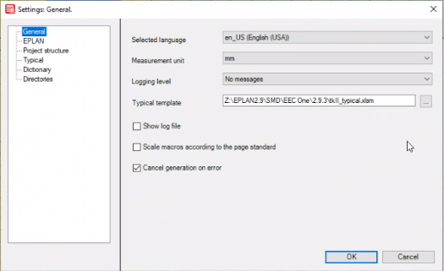

1. Under *Dictionary* tab, set translation database as shown below. After selecting SQL server option click on [**…**] button

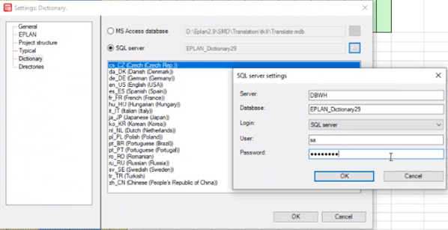

1. Under *Directories* tab, set all directories paths as shown below.

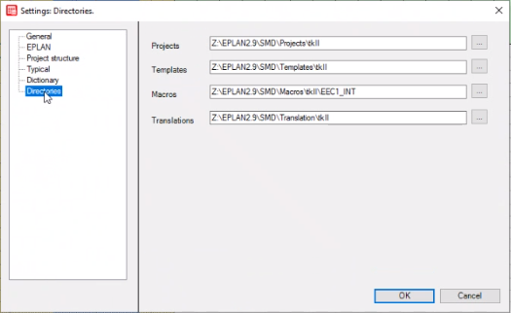

**Process to follow as in toolbar:**

1. Create New project by clicking 1st icon in toolbar
2. Start EEC One by clicking 2rd icon in toolbar and after filling up data in typical file, generate schemes
3. Open Cable navigator, select top-level element and right click. Then select from pop-up menu, Assign cable connection → Reassign all
4. Edit cable route length in template file by clicking 3rd icon in toolbar
5. Calculate cable length by 4th icon in toolbar using “Edit properties externally” function, important to select parameters correctly in next dialog as shown below

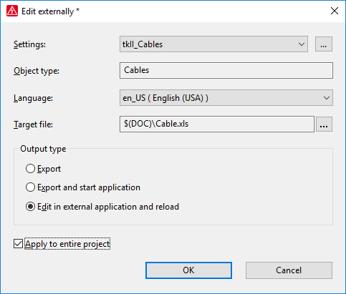

1. Run automated processing by 5th icon in toolbar